Is there a significant difference in Cell Radius, Texture, and smoothness between Malignant and Benign Tumors?
Task B – Statistical Analysis
Normality Test
- H₀ : The variable follows a normal distribution.
- H₁ : The variable does not follow a normal distribution.

1.Radius_mean
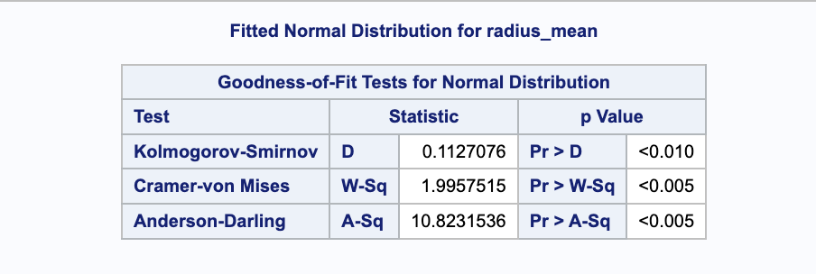
Since p < 0.05 for all tests, we reject the null hypothesis that radius_mean follows a normal distribution.

2.Texture_mean
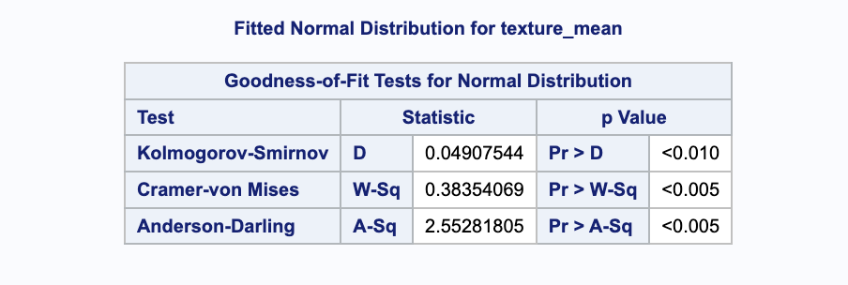
Since p < 0.05 for all tests, we reject the null hypothesis that radius_mean follows a normal distribution.

3.Smoothness_mean
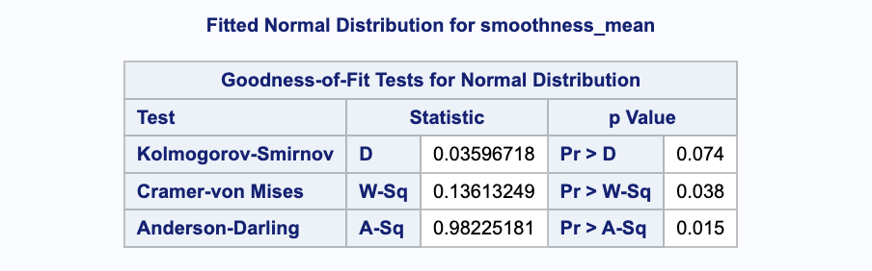
The variable smoothness_mean shows borderline normality. While the Kolmogorov-Smirnov test suggests approximate normality (p = 0.074), both the Cramer-von Mises and Anderson-Darling tests reject the null hypothesis (p<0.05). Therefore, smoothness_mean may not fully satisfy the assumption of normality.

Tests Used
- Kolmogorov-Smirnov
- Cramer-von Mises
- Anderson-Darling
Assumptions
- Data is continuous.
- Sample size is sufficient for reliable goodness-of-fit testing.
Results
- radius_mean and texture_mean: p-values < 0.01 → reject H₀ → not normally distributed
- smoothness_mean: Mixed results; borderline normality (K-S p = 0.074, A-D p = 0.015)

Non-parametric ANOVA
- H₀ : The distributions of the variable are equal across diagnosis groups.
- H₁ : The distributions differ between malignant and benign groups.
1.radius_mean
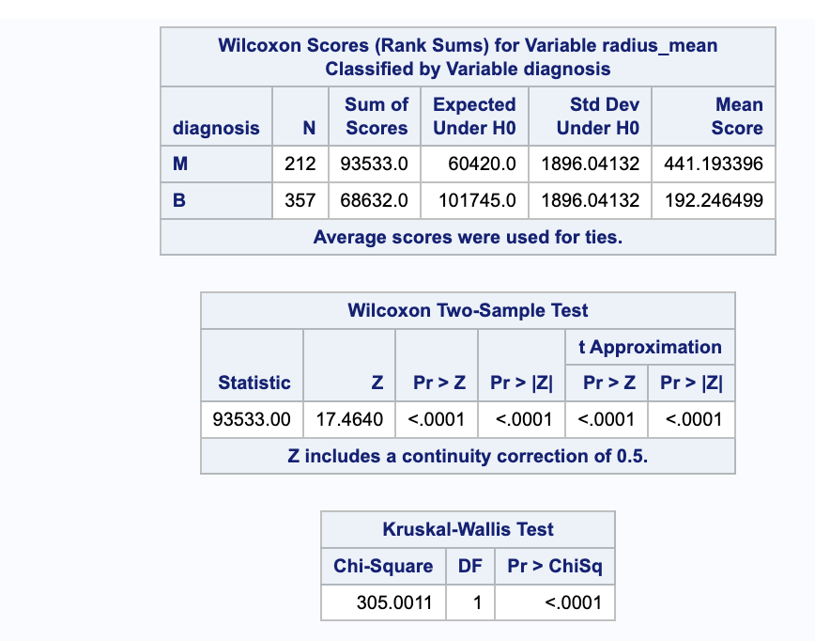
Non-parametric analysis reveals a statistically significant difference in radius_mean between malignant and benign cases (Wilcoxon Z = 17.464, p < 0.0001; Kruskal-Wallis χ2 = 305.0011, p < 0.0001). This suggests that radius_mean is a very strong discriminative feature in breast cancer diagnosis.

2.texture_mean
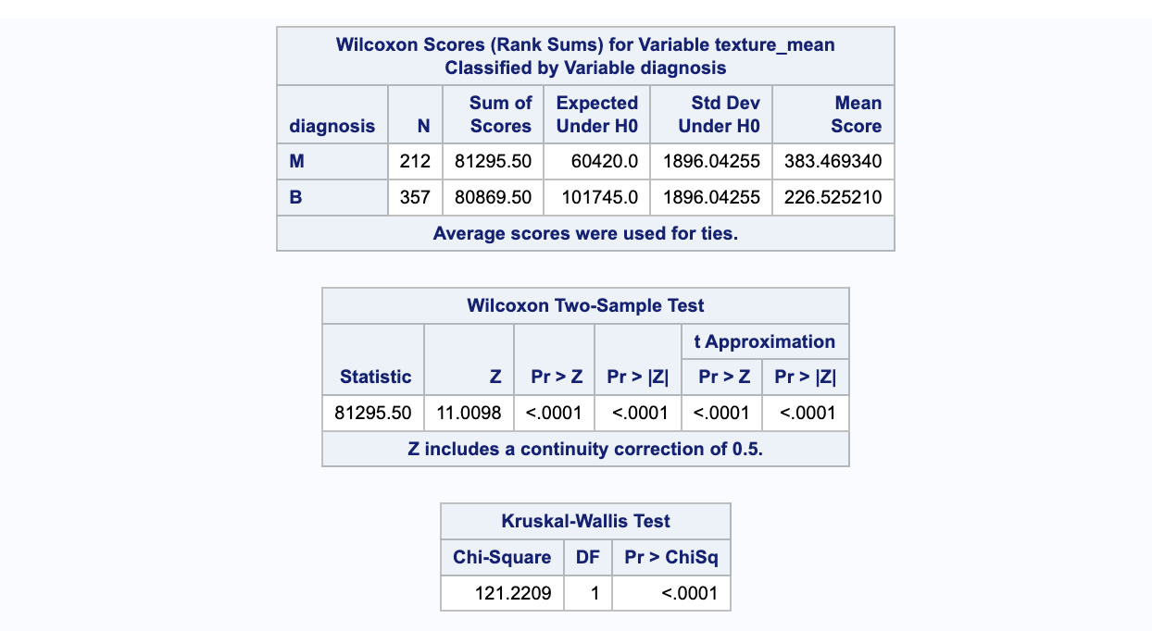
texture_mean differs significantly between malignant and benign diagnoses (Wilcoxon Z = 11.0098, p < 0.0001; Kruskal-Wallis χ² = 121.2209, p < 0.0001). This suggests that texture_mean is a strong discriminative feature in breast cancer diagnosis.
3.smoothness_mean
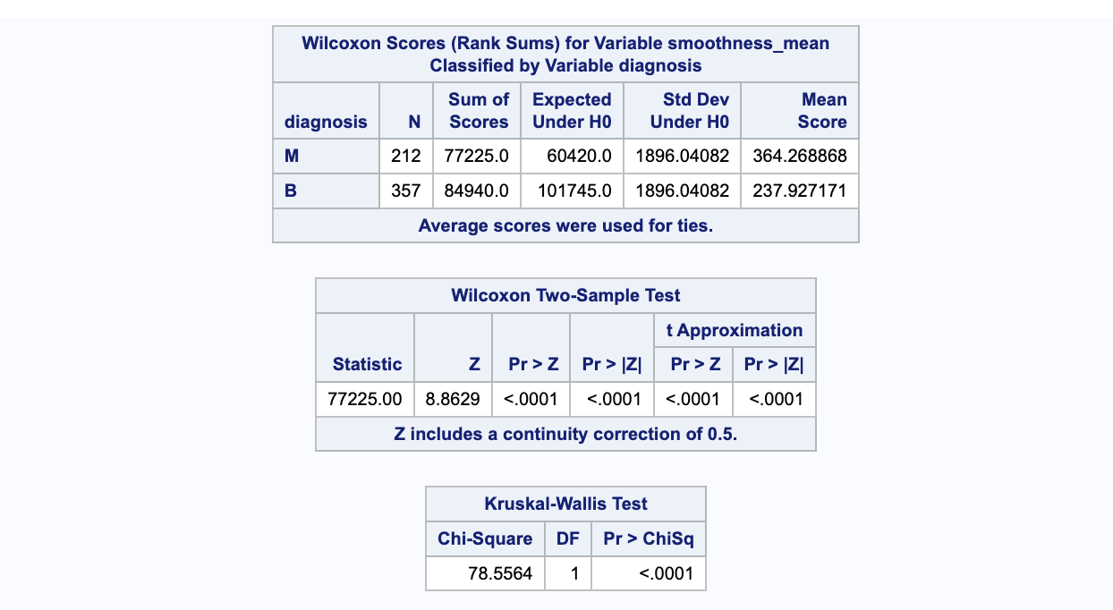
smoothness_mean shows a significant difference between malignant and benign diagnoses (Wilcoxon Z = 8.8629, p < 0.0001; Kruskal-Wallis χ² = 78.5564, p < 0.0001). This suggests that smoothness_mean is a moderate-strong discriminative feature in breast cancer diagnosis
Tests Used
- Wilcoxon Rank-Sum Test (for pairwise comparison)
- Kruskal-Wallis Test (for overall distribution difference)
Assumptions
- Independent samples.
- Ordinal or continuous data.
- No assumption of normality.
Results
Variable | Wilcoxon | Kruskal-Wallis | p-value
Radius_mean | 17.4640 | 305.0011 | < 0.0001
Texture_mean | 11.0098 | 121.2209 | < 0.0001
Smoothness_mean | 8.8629 | 78.5564 | < 0.0001

Conclusion
- All three variables show statistically significant differences between diagnosis groups.
- radius_mean is the strongest discriminator, followed by texture_mean, then smoothness_mean.

T-Test
- H₀ : The mean values of the variable are equal across diagnosis groups.
- H₁ : The mean values differ between malignant and benign groups.

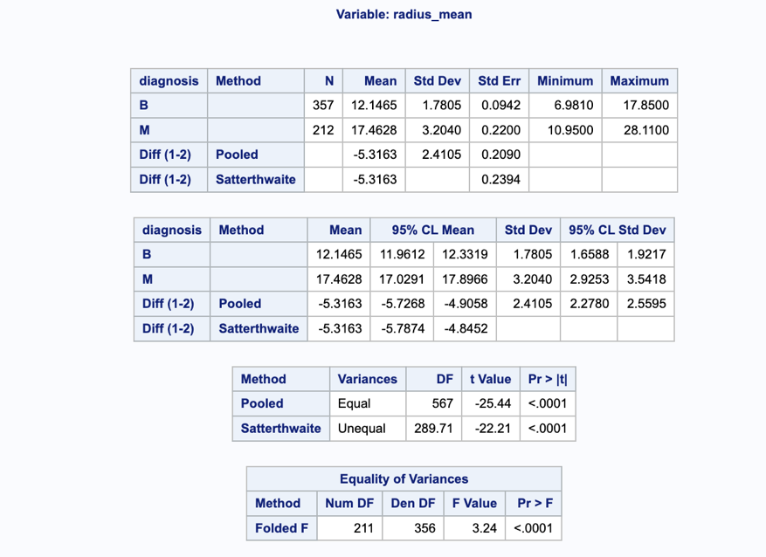
1.Radius_mean

An independent samples T-test revealed a significant difference in radius_mean between malignant and benign cases (t = -22.21, p < 0.0001). The mean radius was substantially higher in malignant tumors (17.46) compared to benign (12.15), confirming its strong diagnostic value.

2.texture_mean
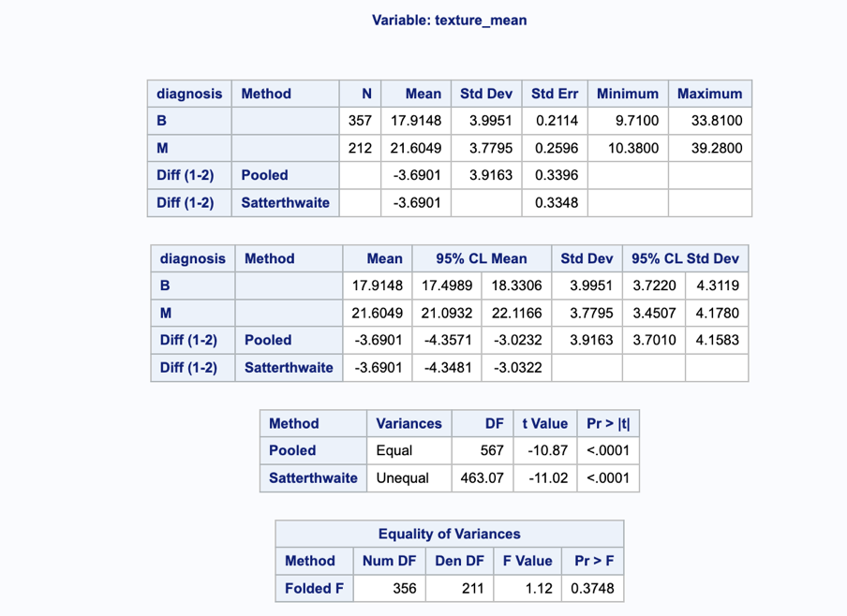
A Two samples T-test revealed a significant difference in texture_mean between malignant and benign cases (t = -11.02, p < 0.0001). Malignant tumors had a higher mean texture (21.60) compared to benign (17.91), supporting its role as a discriminative feature in breast cancer diagnosis.

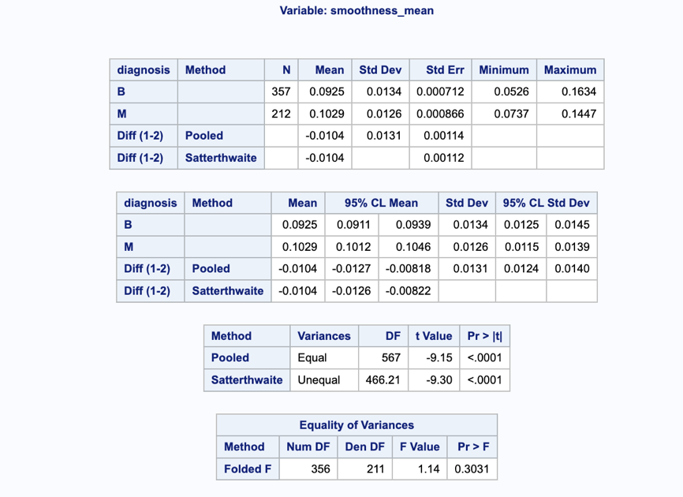
3.smoothness_mean

An independent samples T-test revealed a significant difference in smoothness_mean between malignant and benign cases (t = -9.30, p < 0.0001). Although the mean difference is smaller than other features, it remains statistically meaningful, supporting its diagnostic relevance

Test Used
- Independent Samples T-Test with Satterthwaite approximation (when variances unequal)
Assumptions
- Normality (checked via tests)
- Independent groups
- Homogeneity of variances (tested via Folded F-test)
Results
Variable | Mean(B) | Mean(M) | t-value | p-value
Radius_mean | 12.15 | 17.46 | -22.41 | < 0.0001
Texture_mean | 17.91 | 21.60 | -11.02 | < 0.0001
Smoothness_mean | 0.0925 | 0.1029 | -9.30 | < 0.0001

Conclusion
- All three variables show significant mean differences between malignant and benign groups.
- Confirms their diagnostic relevance in breast cancer classification.

